AIML

PROJECT

Machine Learning Model For Academic Purposes

**Meeting 1**

**Understanding the Problem and User Needs**

**Date:** [Insert Date]  
**Geotag Photo:** []

**Questions & Answers:**

**1. What is the core objective of your project?**  
**Answer:**  
The core objective of our project is to enhance online learning platforms by integrating a semantic search system using Sentence-BERT, which enables accurate query matching and personalized responses for student queries.

**2. What is Sentence-BERT and why was it chosen?**  
**Answer:**  
Sentence-BERT is a modification of the BERT model that enables efficient sentence-level embeddings. It was chosen for its ability to capture semantic meaning and provide better sentence similarity comparisons, making it ideal for matching student queries to the correct answers.

**3. How does your system work at a high level?**  
**Answer:**  
The system takes student queries as input, encodes them using Sentence-BERT, compares them with a dataset of pre-answered questions, computes cosine similarity, and returns the most relevant answer based on semantic similarity.

**4. What technologies did you use in your implementation?**  
**Answer:**  
We used Python, Flask (for the web interface), Pandas (for data handling), SentenceTransformers library (for encoding), and Matplotlib/Seaborn for visualizing similarity and data trends.

**5. How do you ensure the accuracy of matched answers?**  
**Answer:**  
We calculate cosine similarity between the user query and pre-encoded queries from the dataset. The system retrieves the highest similarity score to ensure the most semantically accurate match.

**6. How is the dataset prepared and processed?**  
**Answer:**  
The dataset is an Excel file containing student queries and their corresponding answers. We clean the data by removing null values and encode all queries into embeddings using Sentence-BERT for efficient matching.

**7. Is your project compatible with Google Colab? Why is that important?**  
**Answer:**  
Yes, it is Colab-compatible, allowing users to run the project without local setup. This is crucial for sharing, demonstration, and ensuring platform independence for educational institutions or developers.

**8. What types of visualizations are included in the system?**  
**Answer:**  
The system includes heatmaps for similarity visualization, bar graphs to show matching accuracy, and histograms to analyze query frequency or similarity score distribution.

**9. What are the key benefits of using semantic analysis in education?**  
**Answer:**  
Semantic analysis allows systems to understand student queries more accurately, reducing irrelevant responses and improving personalized learning by retrieving context-aware answers.

**10. What are the future enhancements planned for this system?**  
**Answer:**  
We plan to include voice-to-text query handling, multilingual support, a feedback loop for improving answers over time, and integration with learning management systems (LMS)

**Meeting 2**

**Exploring User Interaction and Usability**

**Date:** [25/01/2025]

**Geotag Photo:**

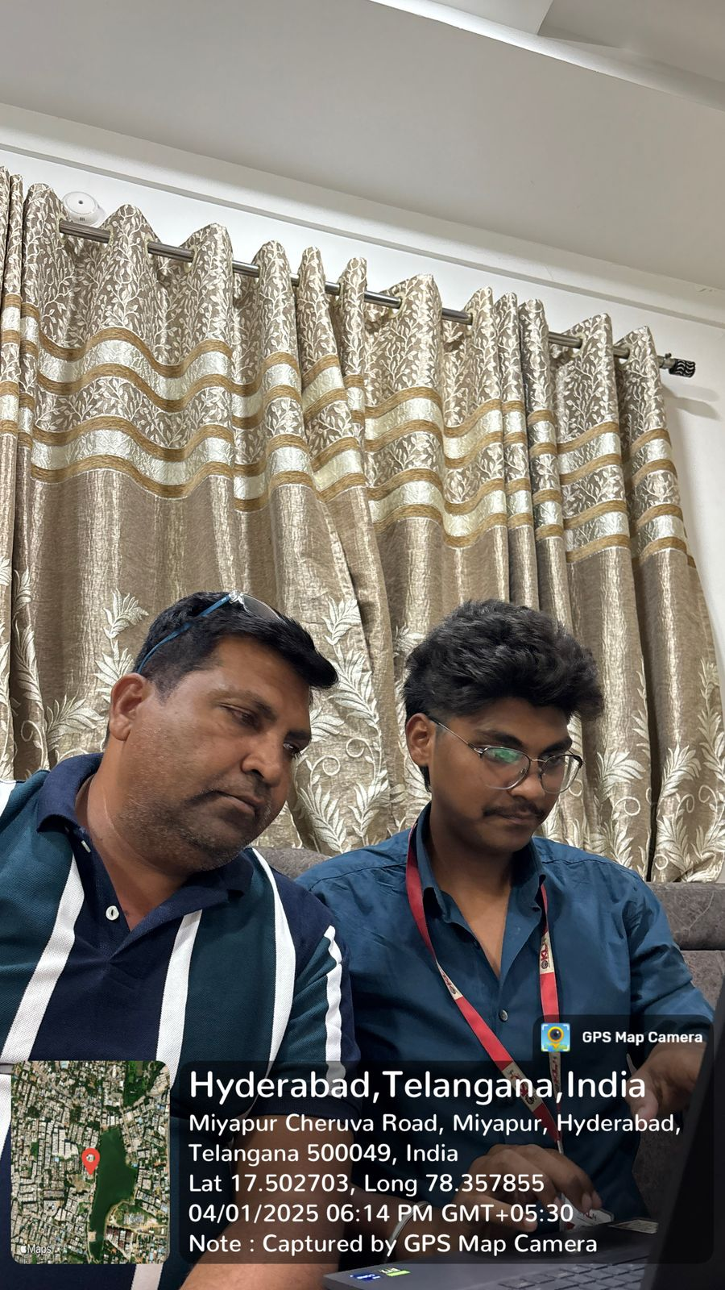

**Questions & Answers:**

**1. How does the user interact with your system?**  
**Answer:**  
The user interacts through a web interface built with Flask. They enter a natural language query into a text input field, and the system returns the most relevant answer from the dataset.

**2. Is the system responsive to different query styles or phrasings?**  
**Answer:**  
Yes, because it uses Sentence-BERT, the system can understand paraphrased queries and still match them correctly by analyzing the semantic meaning rather than relying on keywords.

**3. What happens if the user submits an empty or invalid query?**  
**Answer:**  
The system validates the query input and returns an error message like "Empty query received" if the input is blank, ensuring smooth and error-free interaction.

**4. How quickly does the system respond to user queries?**  
**Answer:**  
The system responds in under one second on average, depending on system resources. Embeddings are pre-computed for the dataset, which optimizes performance.

**5. Can users understand how the answer was selected?**  
**Answer:**  
To enhance transparency, similarity scores can be visualized using bar graphs or heatmaps to show how closely each dataset query matched the user's question.

**6. How is the user experience enhanced through visualization?**  
**Answer:**  
Visualizations such as heatmaps and histograms help users understand trends in their queries, system performance, and confidence levels in match selection.

**7. Is there any feedback mechanism for users?**  
**Answer:**  
Currently, there's no live feedback loop, but it's part of the future roadmap. User feedback could help refine the dataset and improve future responses.

**8. How does the system handle similar queries from multiple users?**  
**Answer:**  
Each query is independently processed using the same semantic embedding approach, ensuring consistency across multiple users even if queries are similar.

**9. Is the interface accessible for non-technical users?**  
**Answer:**  
Yes, the Flask interface is minimalistic and user-friendly. No technical knowledge is required to enter queries and get responses.

**10. Can this system scale to support more users or larger datasets?**  
**Answer:**  
Yes. With infrastructure upgrades (e.g., GPU support, database indexing), the system can be scaled to handle larger datasets and concurrent user sessions.

**Meeting 3**

**Gauging Social Impact and Adoption**

**Date:** [25/02/2025]  
**Geotag Photo:**



**Questions & Answers:**

**1. What is the potential social impact of your project?**  
**Answer:**  
Our system enhances access to quality education by providing personalized and context-aware answers to student queries, bridging the gap in traditional online learning platforms.

**2. Who are the primary beneficiaries of this system?**  
**Answer:**  
Students, educators, and institutions engaged in online education can benefit the most. It helps students get instant doubt clarification and helps educators reduce repetitive answering.

**3. Can this system help underserved or rural communities?**  
**Answer:**  
Yes. The system can be deployed on lightweight platforms like Google Colab and used with minimal infrastructure, making it accessible even in low-resource settings.

**4. What challenges could affect adoption in the real world?**  
**Answer:**  
Challenges include data privacy concerns, need for high-quality domain-specific datasets, and user training for educators and students unfamiliar with AI tools.

**5. How does your system promote inclusive education?**  
**Answer:**  
It supports semantic understanding regardless of language style, making it more inclusive for students with varying levels of linguistic proficiency or educational background.

**6. Has any feedback been received from real users or institutions?**  
**Answer:**  
As a prototype, it is currently in testing. However, initial demonstrations have shown interest from educators for use in doubt resolution and content recommendation.

**7. How would you measure the system’s social success?**  
**Answer:**  
By tracking metrics like improved student engagement, reduced teacher workload, higher student satisfaction, and expansion into new learning environments.

**8. Can this project create new opportunities for teachers?**  
**Answer:**  
Yes. Teachers can use it to automate basic Q&A, focus more on personalized mentoring, and even update the dataset with new knowledge over time.

**9. How does this project align with national or global education goals?**  
**Answer:**  
It supports SDG 4 (Quality Education) by leveraging AI to improve educational quality, promote equity, and support lifelong learning opportunities for all.

**10. What is your long-term vision for social adoption?**  
**Answer:**  
To integrate this semantic AI into existing educational platforms, deploy it in regional languages, and provide affordable, intelligent tutoring for every student.

**Meeting 4**

**Evaluating Future Growth and Potential**

**Geotag Photo:**

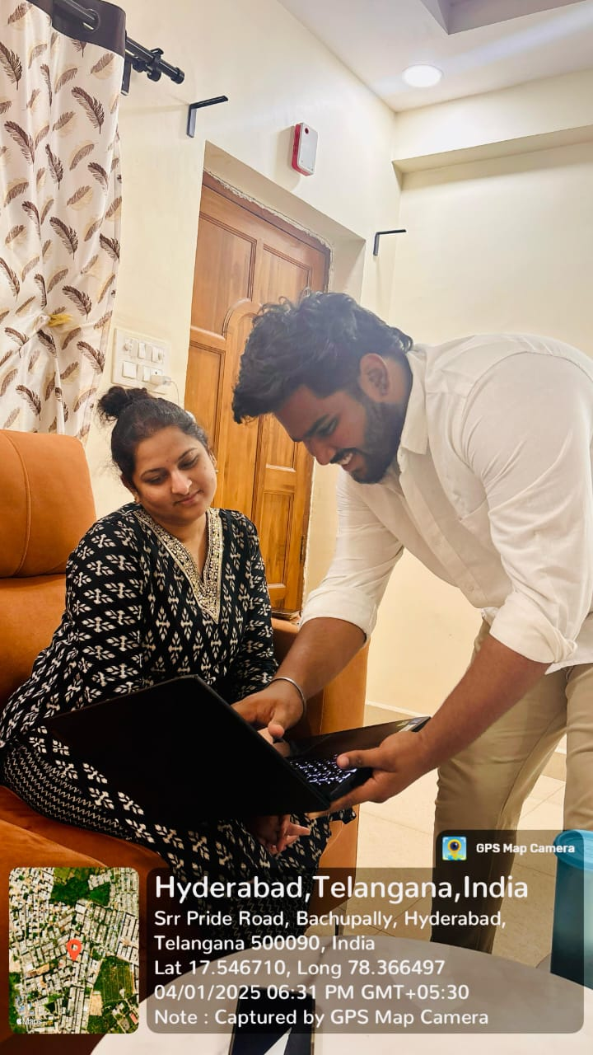

**Questions & Answers:**

**1.What future improvements can be made to your system?**  
**Answer:**  
We plan to implement voice query support, feedback learning loops, multilingual capabilities, and real-time chatbot integration for a more dynamic learning experience.

**2. How scalable is your current architecture?**  
**Answer:**  
The current setup is modular and scalable. By upgrading to GPU-based processing and cloud databases, the system can support larger datasets and more concurrent users.

**3. Can this system be adapted for other domains?**  
**Answer:**  
Yes. With minimal changes to the dataset, the core semantic query-matching engine can be applied to domains like customer support, healthcare, legal services, etc.

**4. What technologies could further enhance this system?**  
**Answer:**  
Incorporating advanced models like GPT-4 for context generation, integrating Natural Language Generation (NLG), and using vector databases for efficient retrieval can greatly enhance performance.

**5. What role can AI ethics play in future development?**  
**Answer:**  
Ensuring data privacy, minimizing biases in the dataset, and maintaining transparency in AI decisions are crucial for responsible scaling and user trust.

**6. How will user feedback influence future versions?**  
**Answer:**  
User feedback will be used to fine-tune model behavior, expand the dataset with real-world questions, and improve interface design for smoother interactions.

**7. What partnerships can help scale the project?**  
**Answer:**  
Collaborations with ed-tech companies, universities, and government bodies could accelerate deployment and adoption across schools and learning platforms.

**8. Can this system evolve into a commercial product?**  
**Answer:**  
Yes. With proper UI/UX, cloud deployment, and continuous improvement, this prototype can be converted into a market-ready AI assistant for online learning platforms.

**9. How can your system contribute to research in AI and education?**  
**Answer:**  
It offers a real-world application of sentence embeddings in education, contributing to studies in AI-based tutoring, semantic search, and human-computer interaction.

**10. What is your ultimate vision for this project?**  
**Answer:**  
To create an intelligent, accessible, and multilingual AI tutor that complements teachers, empowers learners, and evolves with the educational needs of the future.